Project 1: implementing algorithms

CPSC 335 - Algorithm Engineering

Fall 2022

Instructors: Himani Tawade(htawade@fullerton.edu)

# Abstract

In this project you will set up an environment for implementing algorithms in C++, and use that to implement two algorithms that solve the same problem. The first step is for you to become familiar with GitHub and makefiles. We will use GitHub to submit and grade projects all semester. The second step is for you to translate descriptions of two algorithms into pseudocode; analyze your pseudocode mathematically; implement each algorithm in C++; test your implementation; and describe your results. The third step is to do research on the Internet about the usefulness of having a .gitignore file and create the file .gitignore in your directory. Then upload everything on GitHub.

# Installing Tuffix

You can set up Tuffix as a native install on a dedicated computer, or as a virtual machine (VM), by following the [Tuffix Installation Instructions](https://github.com/kevinwortman/tuffix/blob/master/install.md). You can use your own computer, or borrow a computer from CSUF for free through the [Long-Term Laptop Checkout](https://www.fullerton.edu/it/students/equipment/longtermlaptop.php) process.

Another option is CSUF’s [Virtual Computing Lab (VCL)](https://www.fullerton.edu/it/services/vcl/index.php). This allows you to connect remotely to a Tuffix-like environment. Keep in mind a VCL session only lasts a limited time (up to 4 hours) and *is erased at the end of the session,* so you *must save your work elsewhere before your session ends* (e.g. git push all your work before the session ends).

Students using Tuffix should join the [CSUF TUFFIX](https://csuf-tuffix.slack.com) slack workspace at<https://csuf-tuffix.slack.com>. Please use the #general channel to ask about troubleshooting, installing, and using Tuffix.

The smoothest and best-performing option is to install Tuffix natively on a computer, so that is our first recommendation. If that is unfeasible for you, use a VM or VCL. The VM option requires a more powerful computer (especially RAM memory) but saves work indefinitely. VCL requires a stable internet connection and does not save work between sessions.

# Checking This Assignment Prompt For Updates

Assignment prompts are often [living documents](https://en.wikipedia.org/wiki/Living_document). Check back here regularly (and especially before your final submission), to make sure your submission complies with any changes or edits. You may check the top of the document, where the date of the last edit will be noted.

# The Alternating Disk Problem

The problem below is slightly changed from the one presented in Levitin’s textbook as Ex. 14 on page 103:

You have a row of $2n$ disks of two colors, $n$ light and $n$ dark. They alternate: light, dark, light, dark, and so on. You want to get all the light disks to the left-hand end, and all the dark disks to the right-hand end. The only moves you are allowed to make are those that interchange the positions of two adjacent disks (i.e. they touch each other). No other moves are allowed. Design an algorithm for solving this puzzle and determine the number of moves it takes.



The *alternating disks problem* is:

**Input**: a positive integer n and a list of 2n disks of alternating colors light-dark, starting with light

**Output:** a list of 2n disks, the first n disks are light, the next n disks are dark, and an integer m representing the number of swaps to move the dark ones after the light ones.

There are two algorithms, presented below, that solve this problem in O(n2) time. An improvement can be obtained by not going all the way to the left or to the right, since some disks at the ends are already in the correct position. You need to translate the descriptions of the two algorithms into clear pseudocode. You are allowed to do the improvements as long as it does not change the description of the algorithm.

The first algorithm proceeds like a lawnmower: starts with the leftmost disk and proceeds to the right until it reaches the rightmost disk: compares every two adjacent disks and swaps them only if necessary. Now we have two light disks at the left-hand end and two dark disks at the right-hand end. Once it reaches the right-hand end, it starts with the rightmost disk, compares every two adjacent disks and proceeds to the left until it reaches the leftmost disk, doing the swaps only if necessary. The lawnmower movement is repeated (n+1)/2 times. Some improvement can be obtained by not going all the way to the left or to the right, since some disks at the ends are already in the correct position.

The second algorithm has n+1 runs. In each run, every two disks are compared and swap only if necessary. The first run compares the first and second disk, the third and fourth disk, the fifth and the sixth disk, etc.. The second run compares the second and third disk, the fourth and the fifth, the sixth and the seventh disk, etc.. The third run is a repetition of the first run. The fourth run is a repetition of the second run, etc.. Again, swaps are done only if necessary. Run 1, 3, etc. starts with the leftmost disk and proceeds to the right until it reaches the rightmost disk: compares every two adjacent disks and swaps them only if necessary. Now we have one light disk at the left-hand end and the dark disk at the right-hand end. Run 2, 4, etc. starts with the second leftmost disk and proceeds to the right until it reaches the second rightmost disk: compares every two adjacent disks and swaps them only if necessary. There are a total of $n+1$ runs.

## The lawnmower algorithm

It starts with the leftmost disk and proceeds to the right until it reaches the rightmost disk: compares every two adjacent disks and swaps them only if necessary. Now we have two light disks at the left-hand end and two dark disks at the right-hand end. Once it reaches the right-hand end, it starts with the rightmost disk, compares every two adjacent disks and proceeds to the left until it reaches the leftmost disk, doing the swaps only if necessary. The lawnmower movement is repeated ⌈n/2⌉ times.

Consider the example below when n=4, and the first row is the input configuration, the second row is the end of comparison from left to right, the third row is the end of the first run (round trip that contains left to right followed by right to left), etc.. The exact list of disks changes as follows at the end of each run (we consider a run to be a check of adjacent disks from left-to-right or right-to-left) is shown below:











## The alternate algorithm

It starts with the leftmost disk and proceeds to the right until it reaches the rightmost disk: compares every two adjacent disks and swaps them only if necessary. It does not iterate through each index, but iterates over each ***pair*** (i.e., it moves 2 steps at a time). We consider a run to be a check of adjacent disks from left-to-right.

Next it starts with the second leftmost disk and proceeds to the right until it reaches the second rightmost disk: compares every two adjacent disks and swaps them only if necessary. This is the end of Run 2. Now we have two light disks at the left-hand end and two dark disks at the right-hand end. Next it is Run 3 that proceeds exactly as Run 1, starting with the leftmost disk. Run 3 is followed by Run 4 that is exactly as Run 2, starting with the second leftmost disk. So really, Run 1 and Run 2 continually alternate until sorting has finished.

There are a total of n+1 runs.

Consider the example below when n=4, and the first row is the input configuration, the second row is the end of run 1, the third row is the end of run 2, etc.. The exact list of disks changes as follows at the end of each run:











# Algorithm Design

Your first task is to design an algorithm for each of the two problems. Write clear pseudocode for each algorithm. This is not intended to be difficult; the algorithms I have in mind are all relatively simple, involving only familiar string operations and loops or nested loops. Do not worry about making these algorithms exceptionally fast; the purpose of this experiment is to see whether observed timings correspond to Big-Oh trends, not to design impressive algorithms.

# Mathematical Analysis

Your next task is to analyze each of your two algorithms mathematically. You should prove a specific big-O efficiency class for each algorithm. These analyses should be routine, similar to the ones we have done in class and in the textbook. I expect each algorithm’s efficiency class will be one of $O(n),$ $O(n^{2}),$ $O(n^{3}),$ or $O(n^{4}).$

# Obtaining and Submitting Code

This document explains how to obtain and submit your work:

[GitHub Education / Tuffix Instructions](https://docs.google.com/document/d/1XspE5hRtGfc3s66cx0Fhg66PEwub2kY7SlX4lWptVeI/edit?usp=sharing)

Here is the invitation link for this project:

# <https://github.com/himanitawade/project-lawnmover.git>

# Implementation

You are provided with the following files.

1. disks.hpp is a C++ header that defines functions for the two algorithms described above. There are also classes that represent the input and output of the alternating disk problem. The function definitions are incomplete skeletons; you will need to rewrite them to actually work properly.
2. disks_test.cpp is a C++ program with a main() function that performs unit tests on the functions defined in disks.hpp to see whether they work, prints out the outcome, and calculates a score for the code. You can run this program to see whether your algorithm implementations are working correctly.
3. rubrictest.hpp is the unit test library used for the test program; you can ignore this file.
4. README.md contains a brief description of the project, and a place to write the names and CSUF email addresses of the group members. You need to modify this file to identify your group members.(create this file in your repository)

# What to Do

First, add your group members' names to README.md. Then:

1. Write your own pseudocode for the lawnmower and the alternate algorithms.
2. Compute the step count for each algorithm and prove its efficiency class using definition or limit theorem.
3. Implement all the skeleton functions in disks.hpp. Use the disks_test.cpp program to test whether your code works.

Finally, produce a brief written project report ***in PDF format***. Submit your PDF by committing it to your GitHub repository along with your code. Your report should include the following:

1. Your names, CSUF-supplied email address(es), and an indication that the submission is for project 1.
2. A full-screen screenshot, inside Tuffix, showing the Atom editor or the editor you used, with your group member names shown clearly as below. One way to make your names appear in Atom is to simply open your README.md.
3. A full-screen screenshot showing your code compiling and executing.
4. Two pseudocode listings, for the two algorithms, and their step count.
5. A brief proof argument for the time complexity of your two algorithms.

Your screenshot might look like this:

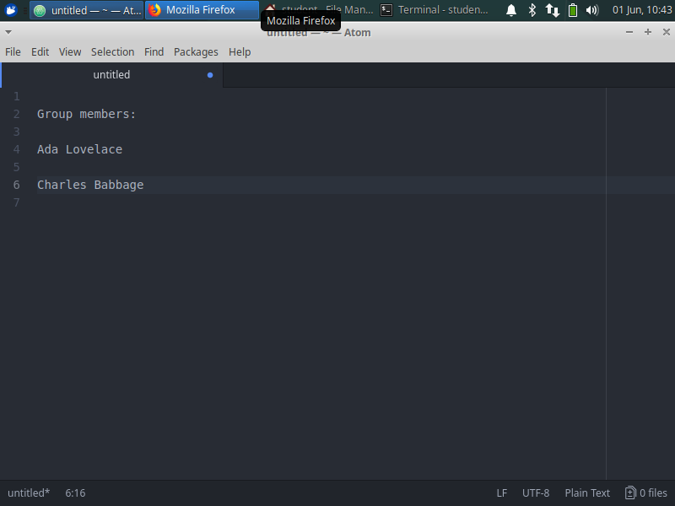

# Grading Rubric

Your grade will consist of three parts: *Form,* *Function,* and *Analysis.*

*Function* refers to whether your code works properly as defined by the test program. We will use the score reported by the test program, when run inside the Tuffix environment, as your Function grade.

*Form* refers to the design, organization, and presentation of your code. A grader will read your code and evaluate these aspects of your submission.

*Analysis* refers to the correctness of your mathematical and empirical analyses, scatter plots, question answers, and the presentation of your report document.

The grading rubric is below.

1. Function = 6 points, scored by the selected tests from the unit test program
2. Form = 11 points, divided as follows:
   1. README.md completed clearly = 3 points
   2. Style (whitespace, variable names, comments, helper functions, etc.) = 3 points
   3. C++ Craftsmanship (appropriate handling of encapsulation, memory management, avoids gross inefficiency and taboo coding practices, etc.) = 3 points
   4. File .gitignore created and populate it correctly = 2 points
3. Analysis = 23 points, divided as follows
   1. Report document presentation = 3 points
   2. Screenshots = 3 points each (total 6 points)
   3. Pseudocode = 3 points each (total 6 points)
   4. Mathematical analysis for each pseudocode = 4 points each (total 8 points)

*Legibility standard:* As stated on the syllabus, submissions that cannot compile in the Tuffix environment are considered unacceptable and will be assigned a 0 score for Function.

# Deadline

The project deadline is Sunday, October 8, 11:59 pm, on GitHub.

You will be graded based on what you have pushed to GitHub as of the deadline. Commits made after the deadline will not be considered. Late submissions will not be accepted unless you use late days and you notify the instructor about using late days.